Project Title:
Visual Analysis of Cancer Patients' Demographics and Diagnoses

1. Open Tableau and Load the Dataset
- Launch Tableau Desktop.
- Go to File > Open, and select the global_cancer_patients.csv
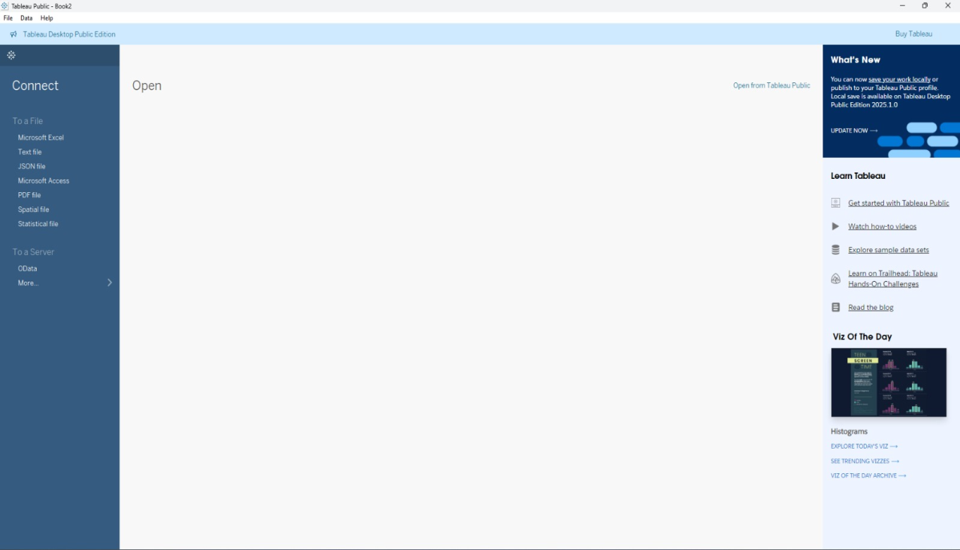

📑 2. Connecting to Data
- Tableau will automatically load the dataset embedded in the .csv file.
- Navigate to the Data Source tab to review the fields, such as:
- Fields Included:
  - Patient ID
  - Age
  - Gender
  - Cancer Type
  - Diagnosis Date
  - Hospital Name
  - Region
  - Treatment Type (if available)
1. What is the average age of cancer patients across different cancer types, and how does this vary by type?

Sheet 1: Average age by Cancer

Step 2: Load Dimensions and Measures
- Verify fields like:
  - Age (Measure)
  - Cancer Type (Dimension)
  - Other fields like Gender, Country, etc.
Step 3: Create a New Worksheet
- Click on the tab “Sheet 1” or click the new worksheet icon.
- Rename the sheet to "Average Age by Cancer Type".
Step 4: Drag Fields into Columns and Rows
- Drag Cancer Type from the Data pane to the Columns shelf.
- Drag Age from the Data pane to the Rows shelf.
- Tableau will default to SUM(Age).
  - Click on the pill, choose “Measure” > “Average” to get AVG(Age).
Step 5: Customize the Visualization
- Set chart type to Bar Chart (if not automatically applied).
- Update title to:
"Average Age by Cancer Type"
(Right-click the title > Edit Title)
Step 6: Formatting and Labels
- Click on the Label in Marks pane to show values.
- Adjust font size, alignment, or number format as needed.
Step 7: Optional Enhancements
- Add color by dragging Cancer Type to Color (for better distinction).
- Add filter (e.g., Gender or Year) if interactivity is needed.
- Sort bars by average age (descending or ascending) using the sort button.

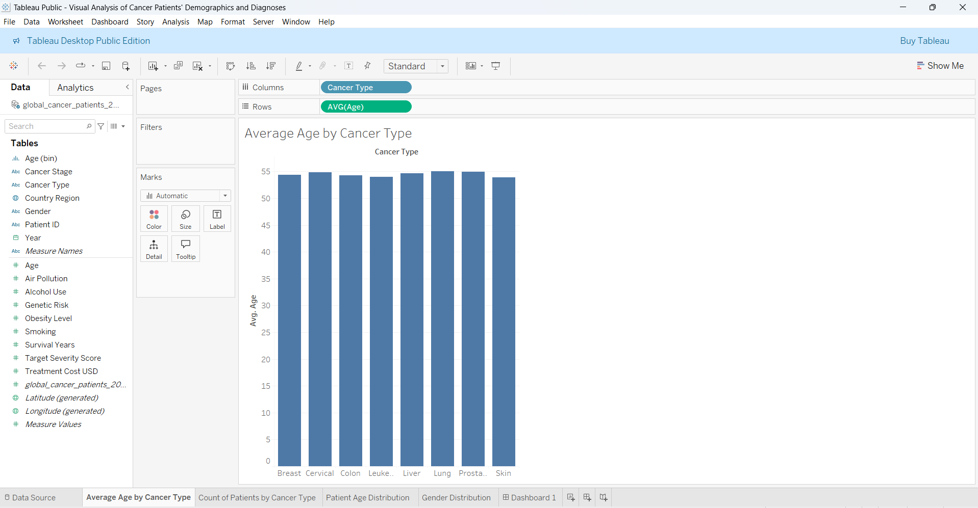

2. What is the distribution of cancer patients across different cancer types, and how does this vary by gender?
Sheet 2: Count of Patients by Cancer Type
Step 2: Create a New Worksheet
- Click the new worksheet icon (bottom tab).
- Rename the sheet as "Count of Patients by Cancer Type".
Step 3: Build the Chart
- Drag Cancer Type to the Columns shelf.
- Drag Patient ID to the Rows shelf.
- Click on the Patient ID pill and change the aggregation to "Count (Distinct)".
  - This gives CNTD(Patient ID).
- Drag Gender to the Color mark in the Marks pane to split each bar by gender.

Step 4: Customize the Chart
- Chart Type: Tableau will auto-select stacked bar chart when you add a dimension to Color. Keep this format.
- Title: Double-click the title and change it to:
"Count of Patients by Cancer Type"
- Legend: Gender categories (Female, Male, Other) are automatically shown.
Step 5: Format the View
- Adjust color scheme for better visibility:
  - Female: Pink/Red
  - Male: Blue
  - Other: Orange (or custom)
- Enable labels (optional): Click Label in Marks pane > Check "Show mark labels"
- Adjust axis formatting if needed.
Step 6: Add Filters (Optional)
- You can add filters like:
  - Year
  - Age Group
  - Region
- Drag them to the Filters shelf or add them as interactive dashboard filters.

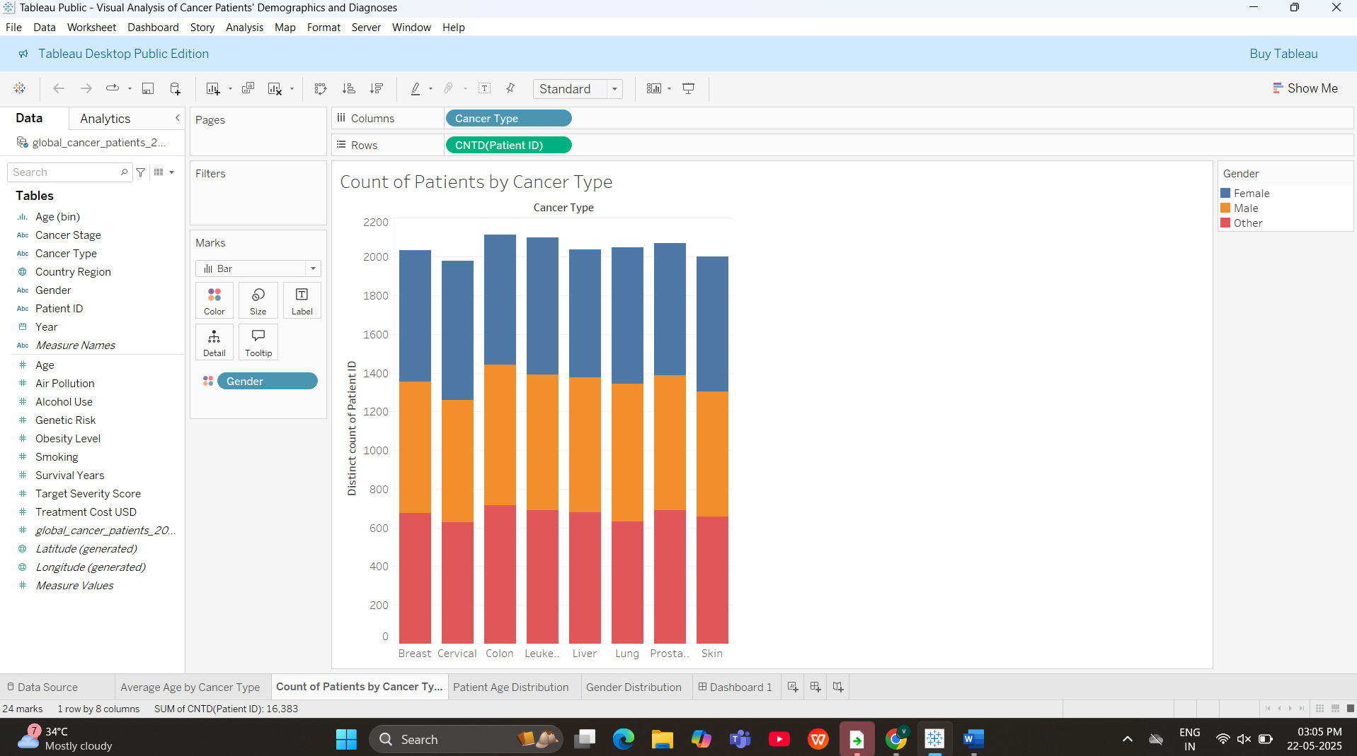

3. How are cancer patients distributed across different age groups, and which age ranges show higher or lower incidence?
Sheet 3: Patient age distribution
Step 2: Create a New Worksheet
- Click the new worksheet tab.
- Rename the worksheet as “Patient Age Distribution”.
Step 3: Create Age Bins
- Right-click on Age in the Data pane.
- Select Create > Bins…
- In the dialog box:
  - Name: Age (bin)
  - Size of bins: 5 or 10 (as appropriate)
  - Click OK.

Step 4: Build the Line Chart
- Drag Age (bin) to the Columns shelf.
- Drag Patient ID to the Rows shelf.
- Right-click on Patient ID pill and change aggregation to "Count (Distinct)" to get CNTD(Patient ID).
- In the Marks pane, select Line chart type.
Step 5: Customize the Chart
- Title: Double-click the title and rename it:
"Patient Age Distribution"
- Tooltip: Hover to ensure tooltips display correct values.
- Axis Formatting: Ensure the x-axis shows age ranges clearly.
Step 6: Optional Enhancements
- Add filters such as:
  - Gender
  - Cancer Type
- Add color (optional) to compare distributions by gender or type.

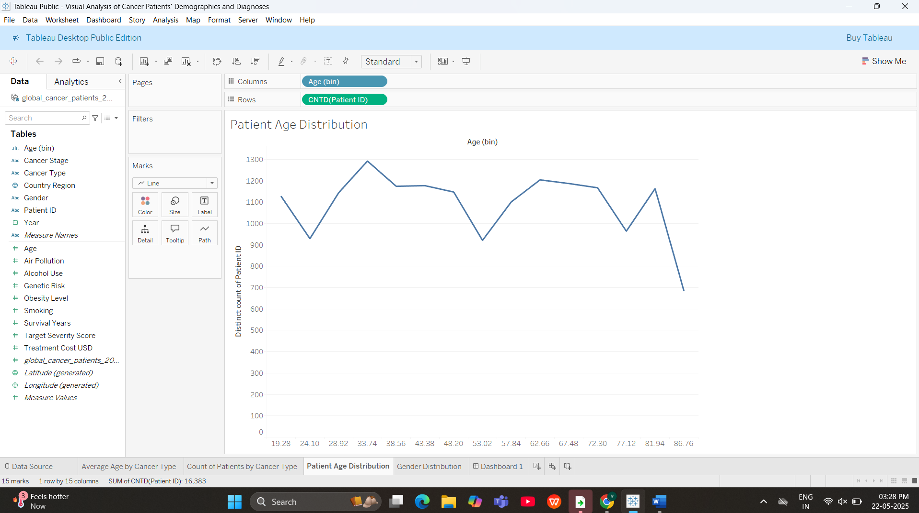

4.What is the gender-wise distribution of cancer patients in the dataset?
Sheet 4:Gender distribution
Step 2: Create a New Worksheet
- Click the new worksheet tab.
- Rename the worksheet to: Gender Distribution

Step 3: Build the Pie Chart
- Drag Gender to the Color mark in the Marks pane.
- Drag Patient ID to the Rows shelf.
- Right-click Patient ID and choose Measure > Count (Distinct).
- Drag the CNTD(Patient ID) field from Rows and drop it into Angle on the Marks card.
- In the Marks dropdown, choose Pie chart.
- Optionally, drag Gender to Label to show category names.
Step 4: Customize
- Title: Double-click the title and rename to:
"Gender Distribution of Cancer Patients"
- Adjust the size of the pie using the Size mark.
- Format labels to show percentages and counts (right-click the label > Format).
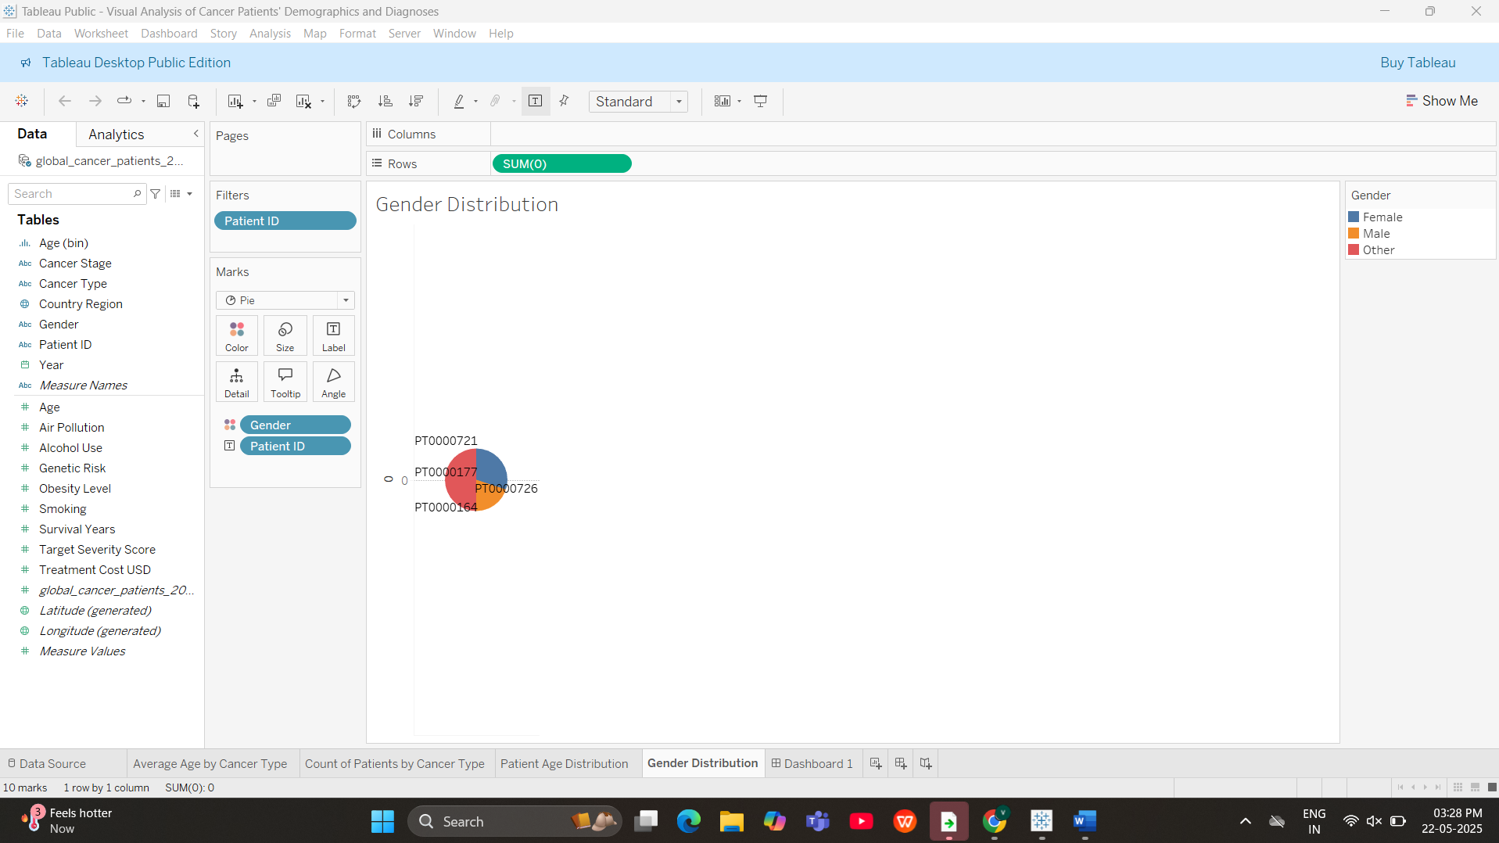
Dashboard:
Step 3: Create the Dashboard
- Click the Dashboard tab at the bottom → Select New Dashboard.
- Set device preview to Desktop Browser (1000 x 800).
- Drag and drop the following sheets into the layout:
  - Average Age by Cancer Type (Top-Left)
  - Patient Age Distribution (Top-Right)
  - Gender Distribution (Bottom-Left)
  - Count of Patients by Cancer Type (Bottom-Right)
